**JUnit Testing:**

**Exercise 1: Setting Up Junit**

**pom.xml**

<dependencies>

<dependency>

<groupId>junit</groupId>

<artifactId>junit</artifactId>

<version>4.13.2</version>

<scope>test</scope>

</dependency>

</dependencies>

**Test Class: Calculator.java**

public class Calculator {

public int add(int a, int b) {

return a + b;

}

}

**CalculatorTest.java**

import org.junit.Test;

import static org.junit.Assert.*;

public class CalculatorTest {

public void testAdd() {

Calculator calc = new Calculator();

int result = calc.add(5, 3);

assertEquals(8, result);

}}

**OUTPUT:**

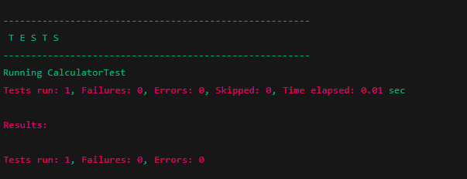

**Exercise 3: Assertions in Junit**

**pom.xml**

<dependencies>

<dependency>

<groupId>junit</groupId>

<artifactId>junit</artifactId>

<version>4.13.2</version>

<scope>test</scope>

</dependency>

</dependencies>

**AssertionsTest.java**

import org.junit.Test;

import static org.junit.Assert.*;

public class AssertionsTest {

public void testAssertions() {

// Assert equals

assertEquals(5, 2 + 3);

// Assert true

assertTrue(5 > 3);

// Assert false

assertFalse(5 < 3);

// Assert null

assertNull(null);

// Assert not null

assertNotNull(new Object());

}

}

**OUTPUT:**

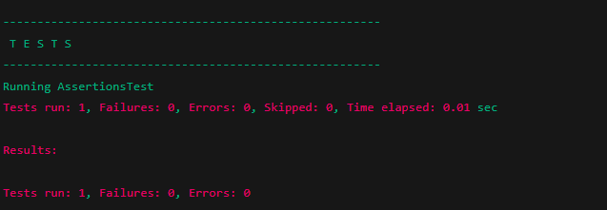

**Exercise 4: Arrange-Act-Assert (AAA) Pattern, Test Fixtures, Setup and Teardown Methods in JUnit**

**Calculator.java**

public class Calculator {

public int add(int a, int b) {

return a + b;

}

public int subtract(int a, int b) {

return a - b;

}

}

**Calculatortest.java**

import org.junit.After;

import org.junit.Before;

import org.junit.Test;

import static org.junit.Assert.*;

public class CalculatorTest {

private Calculator calculator;

public void setUp() {

System.out.println("Setting up calculator...");

calculator = new Calculator(); // Arrange

}

public void tearDown() {

System.out.println("Tearing down...");

calculator = null;

}

public void testAddition() {

int result = calculator.add(5, 3);

assertEquals(8, result);

}

public void testSubtraction() {

int result = calculator.subtract(10, 4);

assertEquals(6, result);

}

**OUTPUT:**

